Lab 6: Lab Report

John Bretz

Dr. Varnell

Abstract

The game uses the four normal processes: slow clock, register, next state logic and output logic. Two state machines were used, one to track the current player an the other to track the actual game. In the next state logic, it first checks that the inputs are valid, and the appropriate values are updated, and player changed when next turn is pressed. The game enters a win or lose state based on whose turn it is when there are no coins left in any of the piles. If the input is not valid than the next turn button is ignored until the input is valid. The output logic displays the current player and the number of coins in each pile or which player won if in a win or lose state.

Circuits

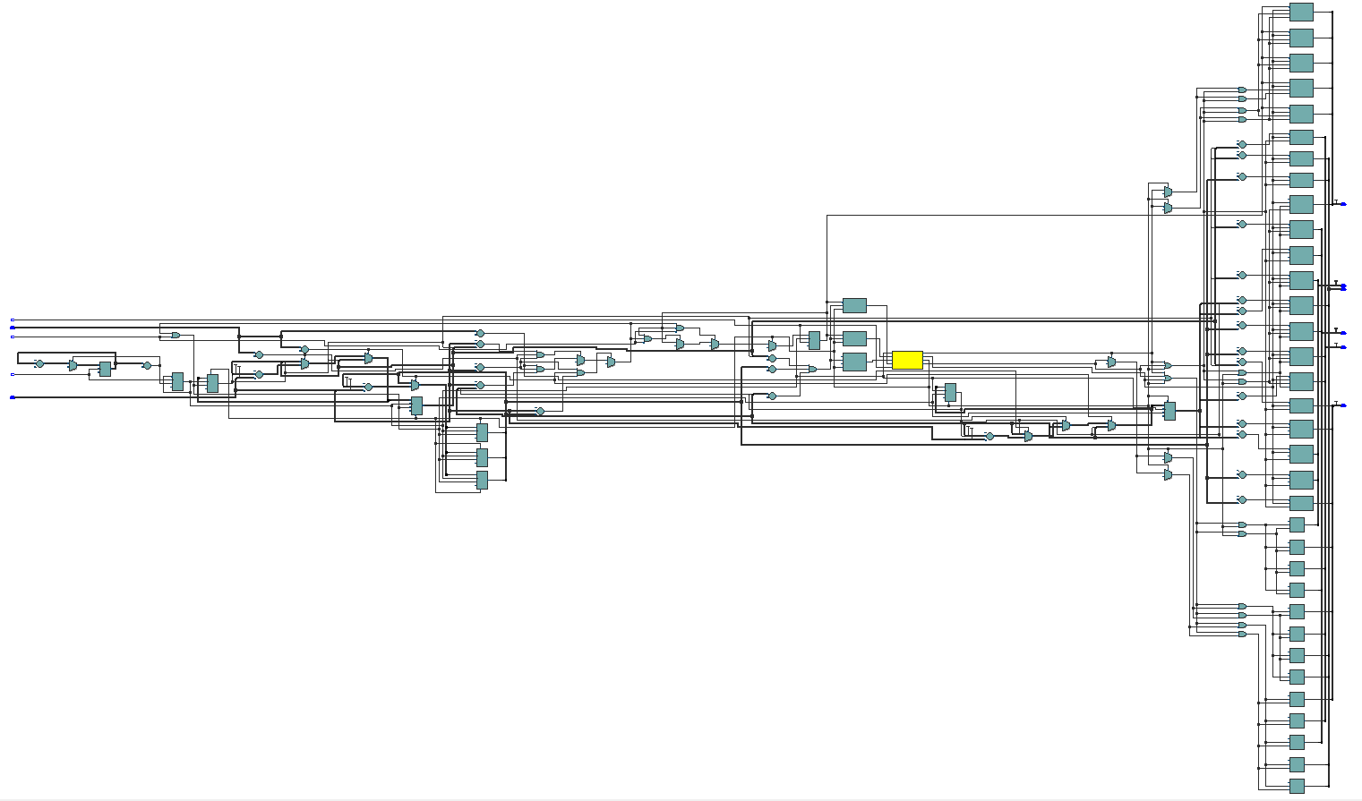

Conclusion

During this lab I learned how to do arithmetic with VHDL and how to convert a vector to an unsigned numeric into an integer to do that arithmetic.